Day-10

Name _ Rishabh Manchanda  
  
Employee ID:

109883998

What is a process?

In Java, a process represents an executing program or application, distinct from a thread. While a Java application typically runs within a single Java Virtual Machine (JVM) process, it can interact with and even create new operating system-level processes.

* **Executing an external operating system command:** Java's Runtime.getRuntime().exec() method or ProcessBuilder class can be used to launch and interact with external programs or commands. For example, executing "notepad.exe" on Windows or "ls" on Linux creates a new operating system process separate from the Java Virtual Machine (JVM) process.

Java

import java.io.IOException;

public class ExternalProcessExample {

public static void main(String[] args) {

try {

// Example 1: Launching Notepad

Process process1 = Runtime.getRuntime().exec("notepad.exe");

System.out.println("Notepad launched.");

// Example 2: Running a simple command (e.g., 'ls' on Linux/macOS or 'dir' on Windows)

// Replace "ls -l" with "cmd /c dir" for Windows

Process process2 = Runtime.getRuntime().exec("ls -l");

System.out.println("Directory listing command executed.");

} catch (IOException e) {

e.printStackTrace();

}

}

}  
  
Task 2   
What is a thread?

A thread is a smaller part of a process that helps a program do many tasks at the same time. For example, in a web browser (which is a process), one thread might load a webpage, another might play a video.

Task 3

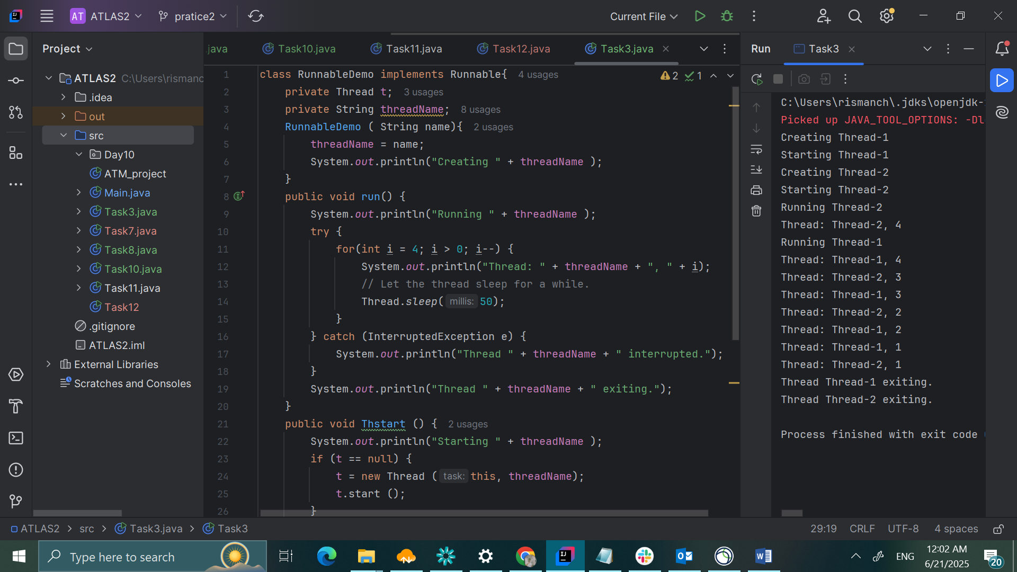

TASK4

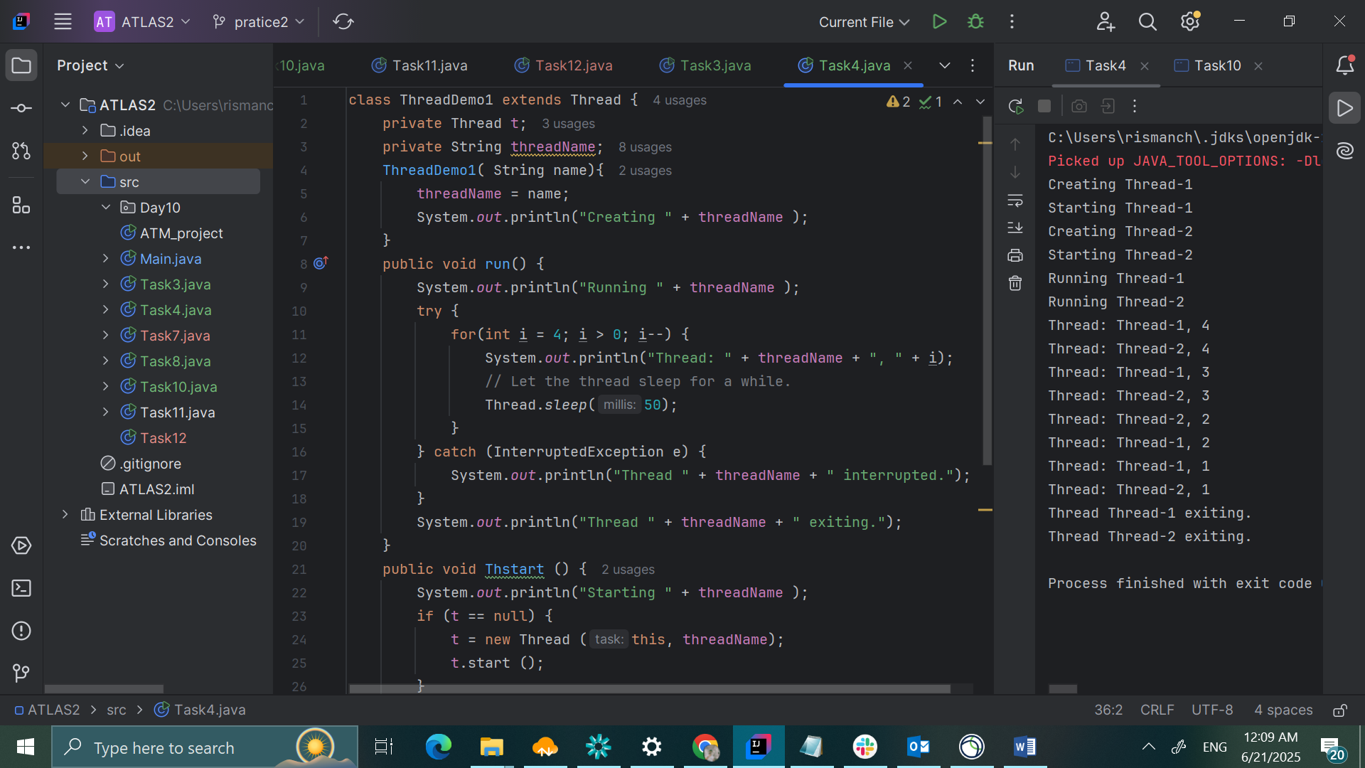

Task5

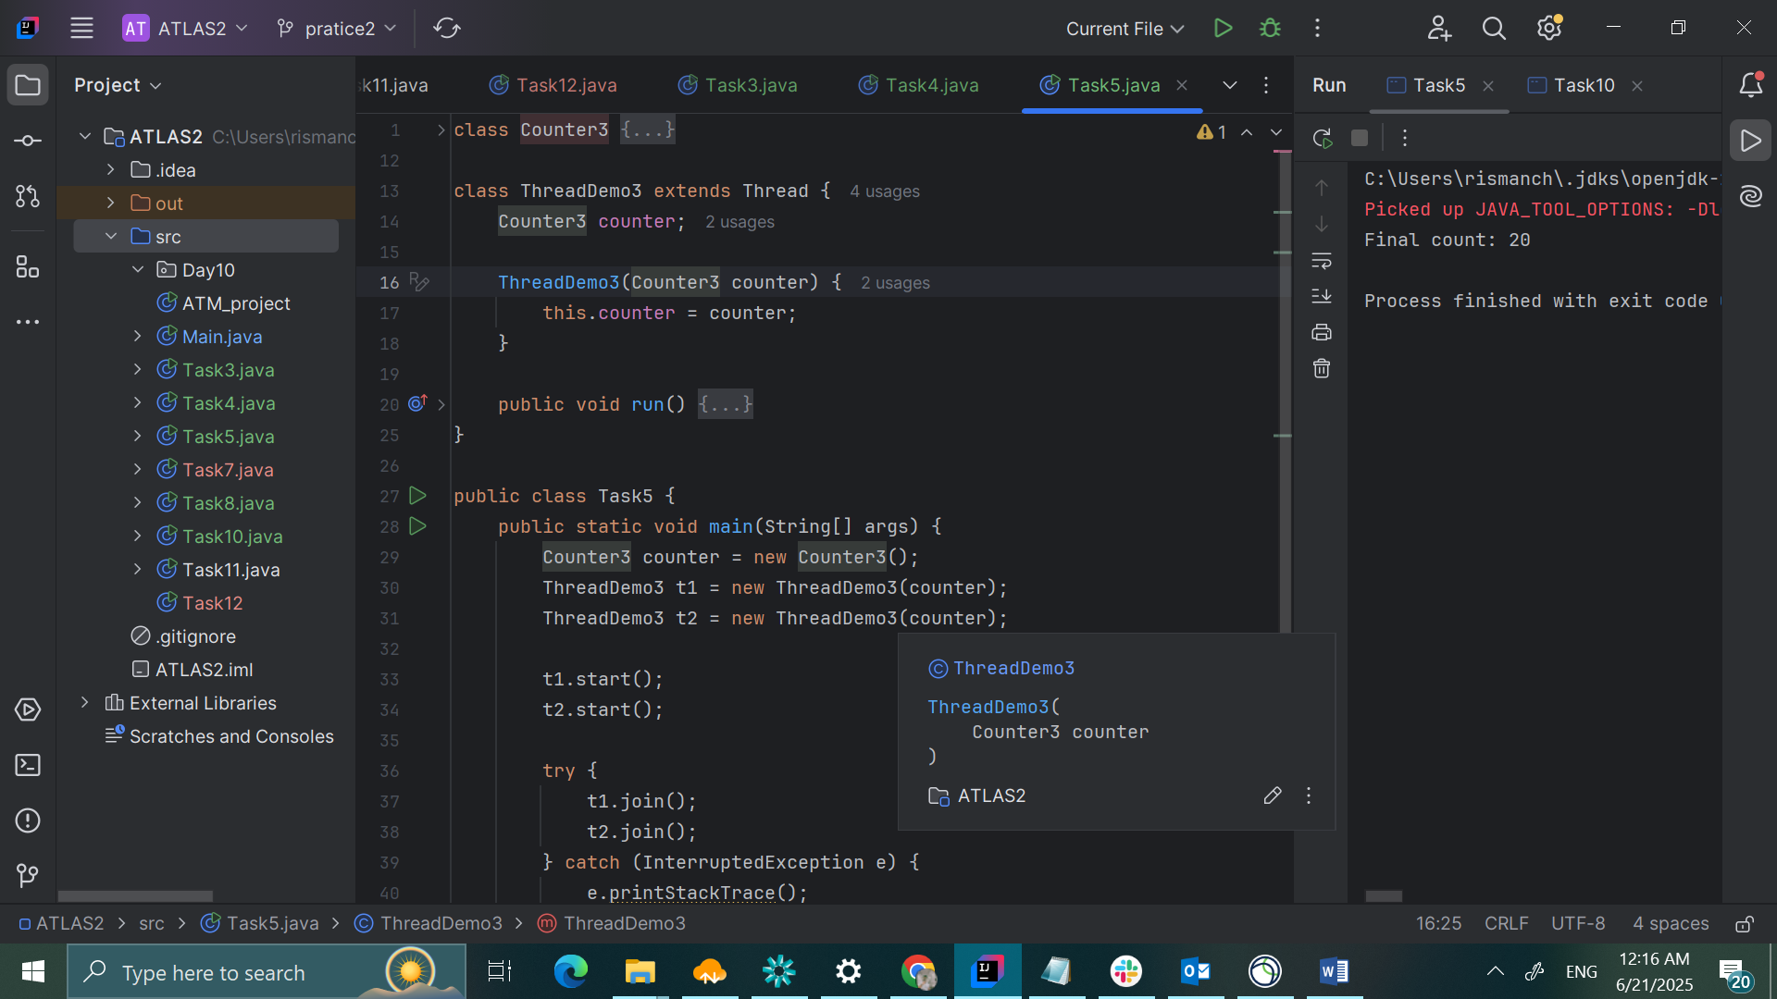

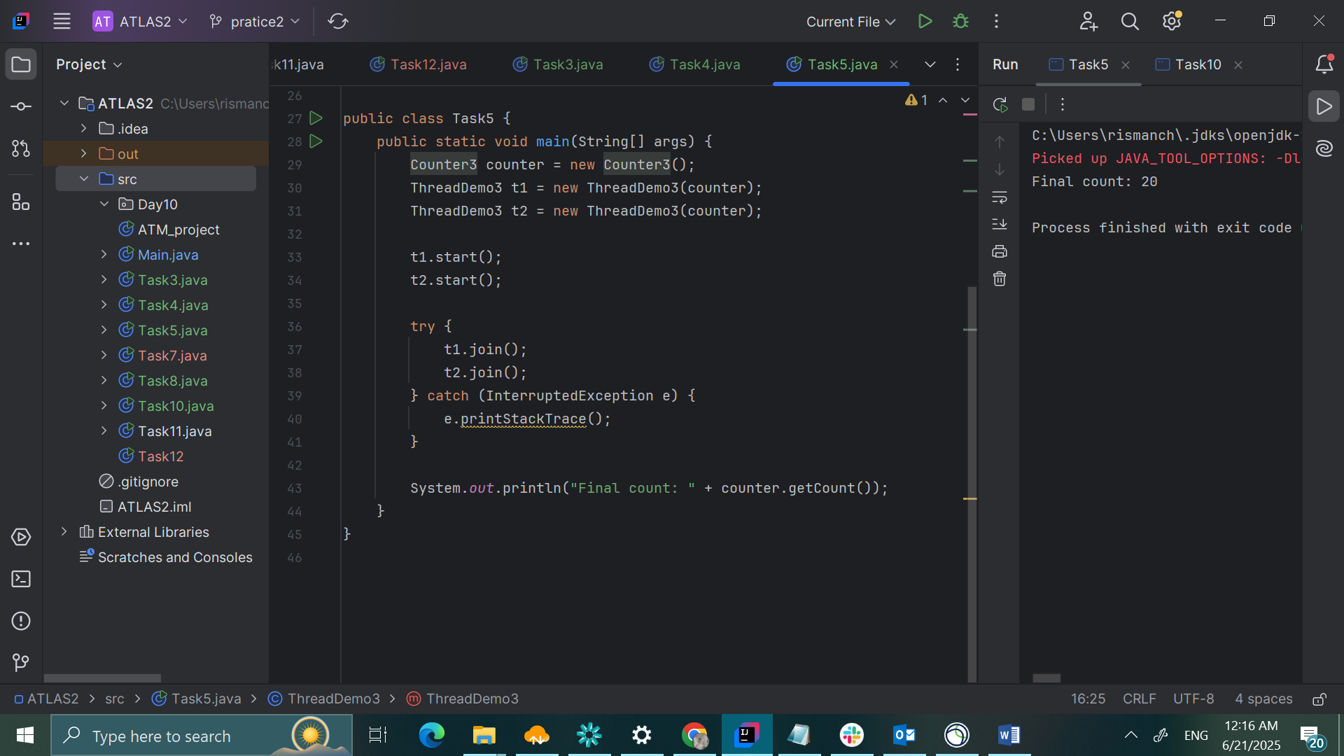

TASK7

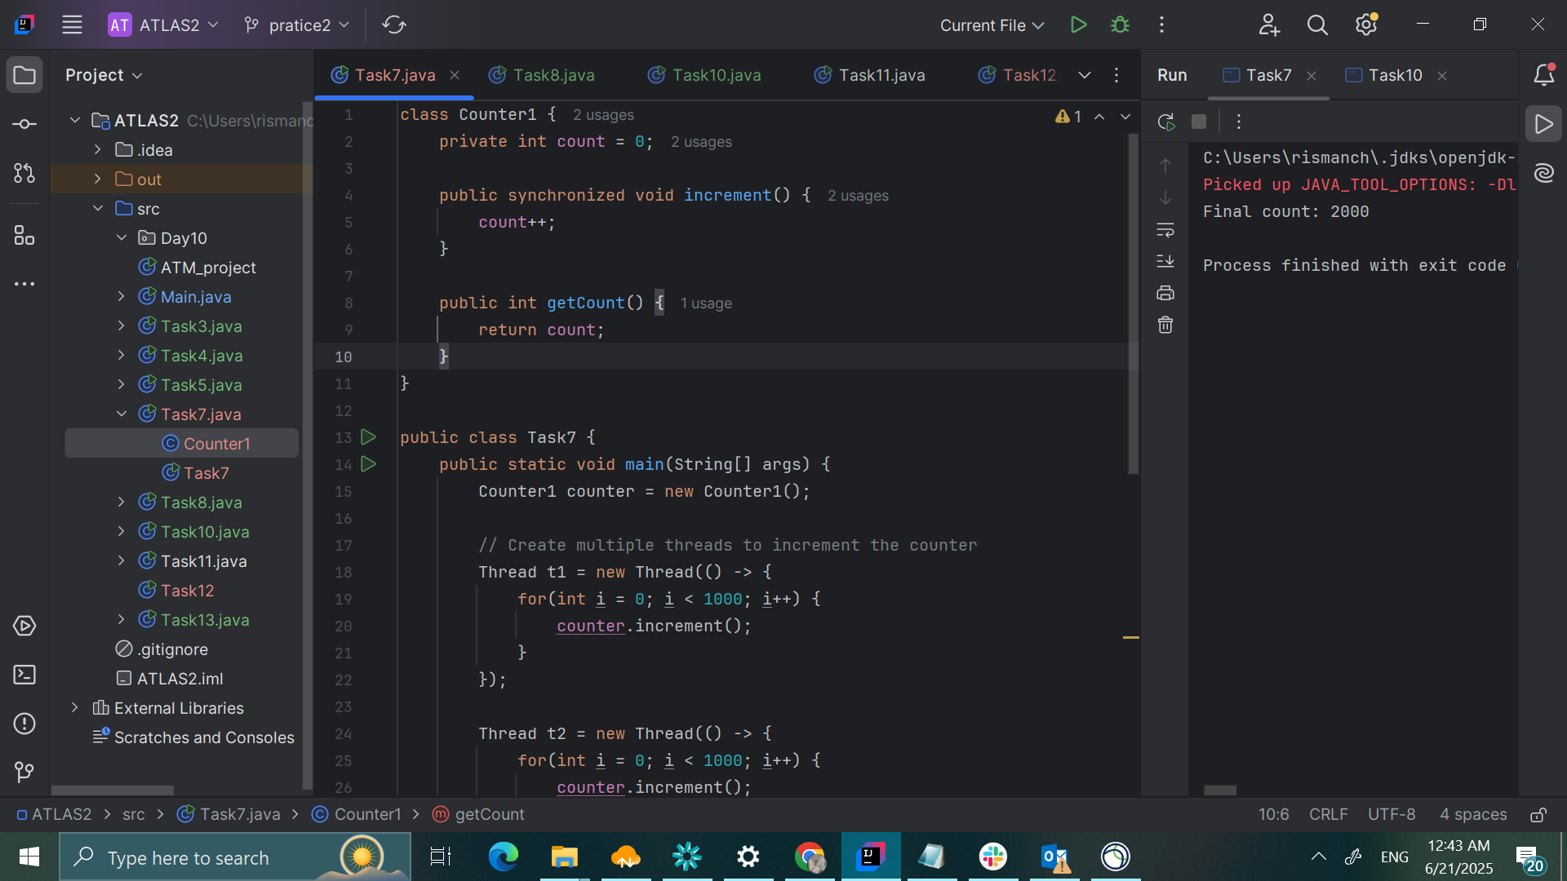

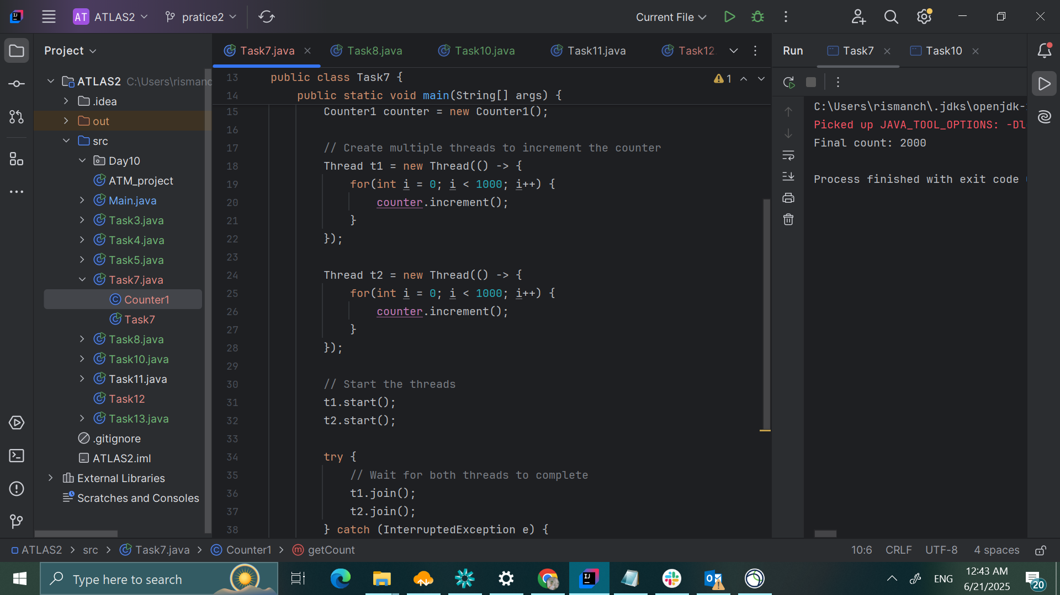

TASK8

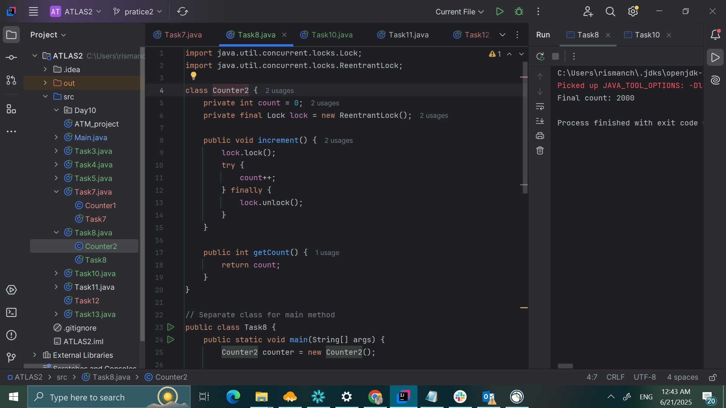

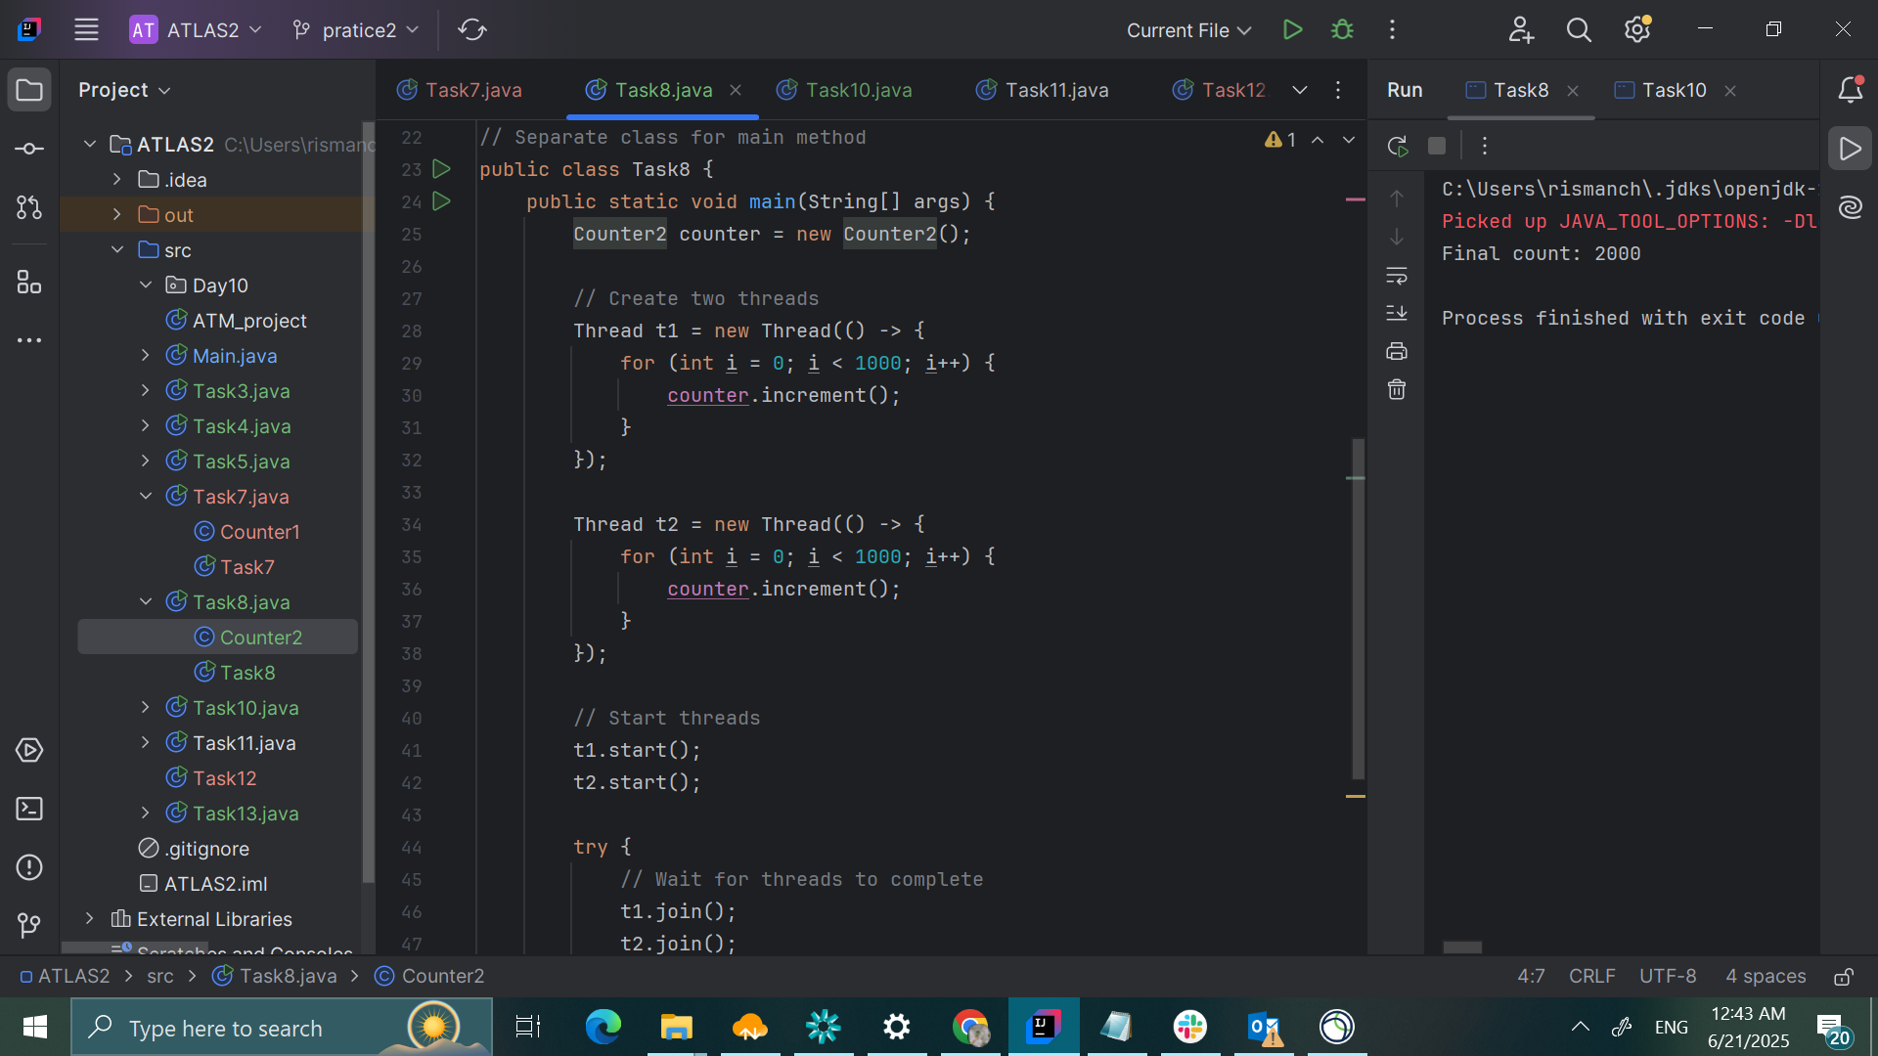

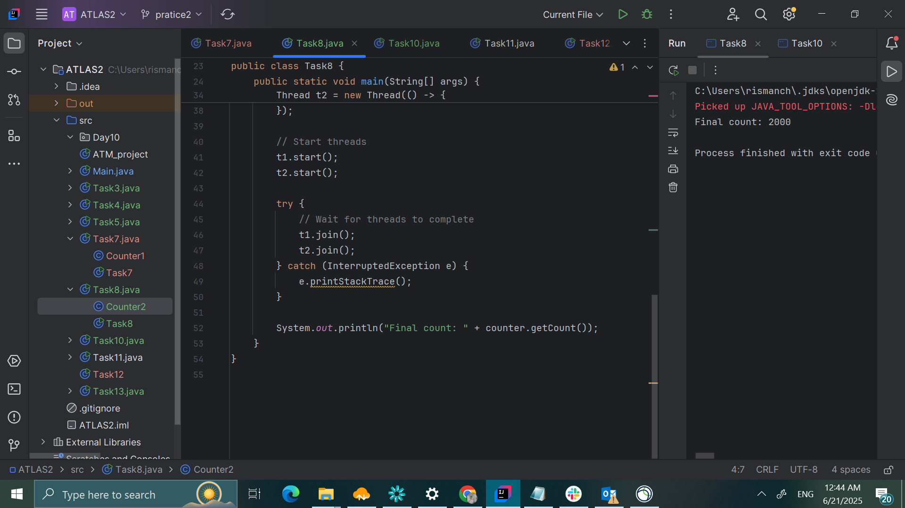

TASK9

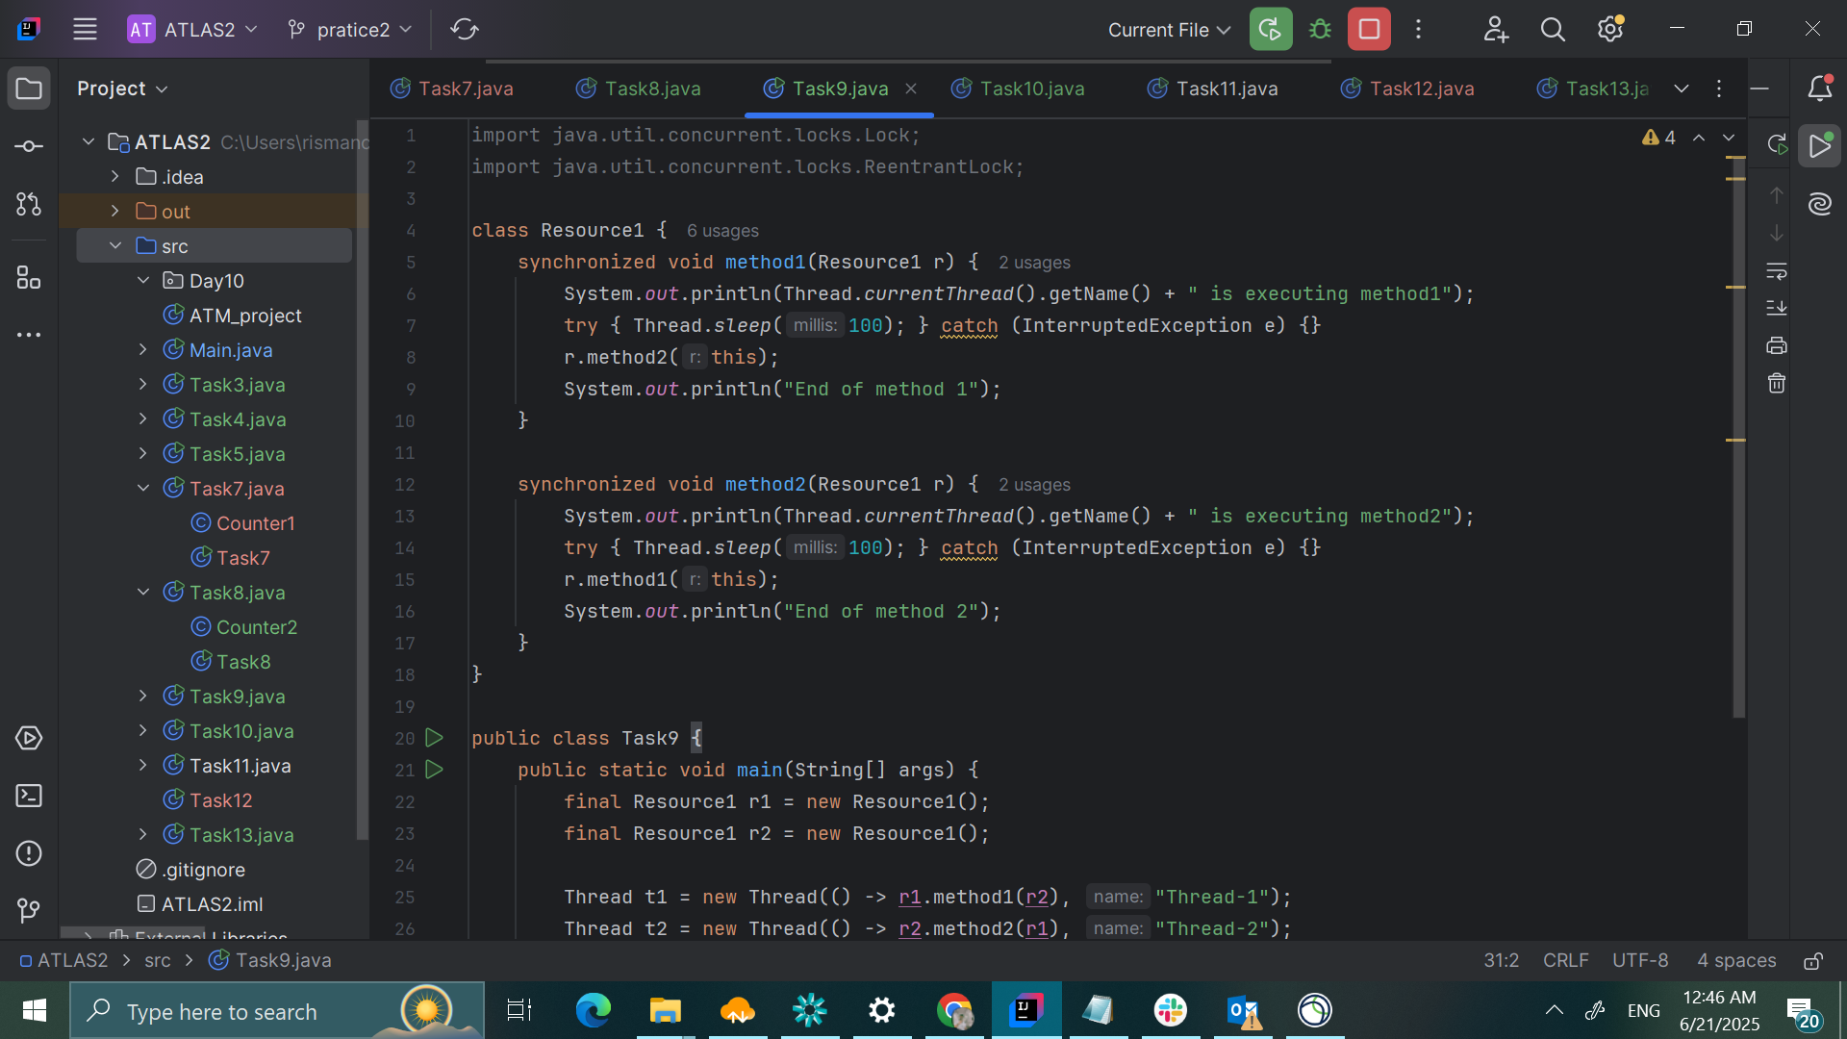

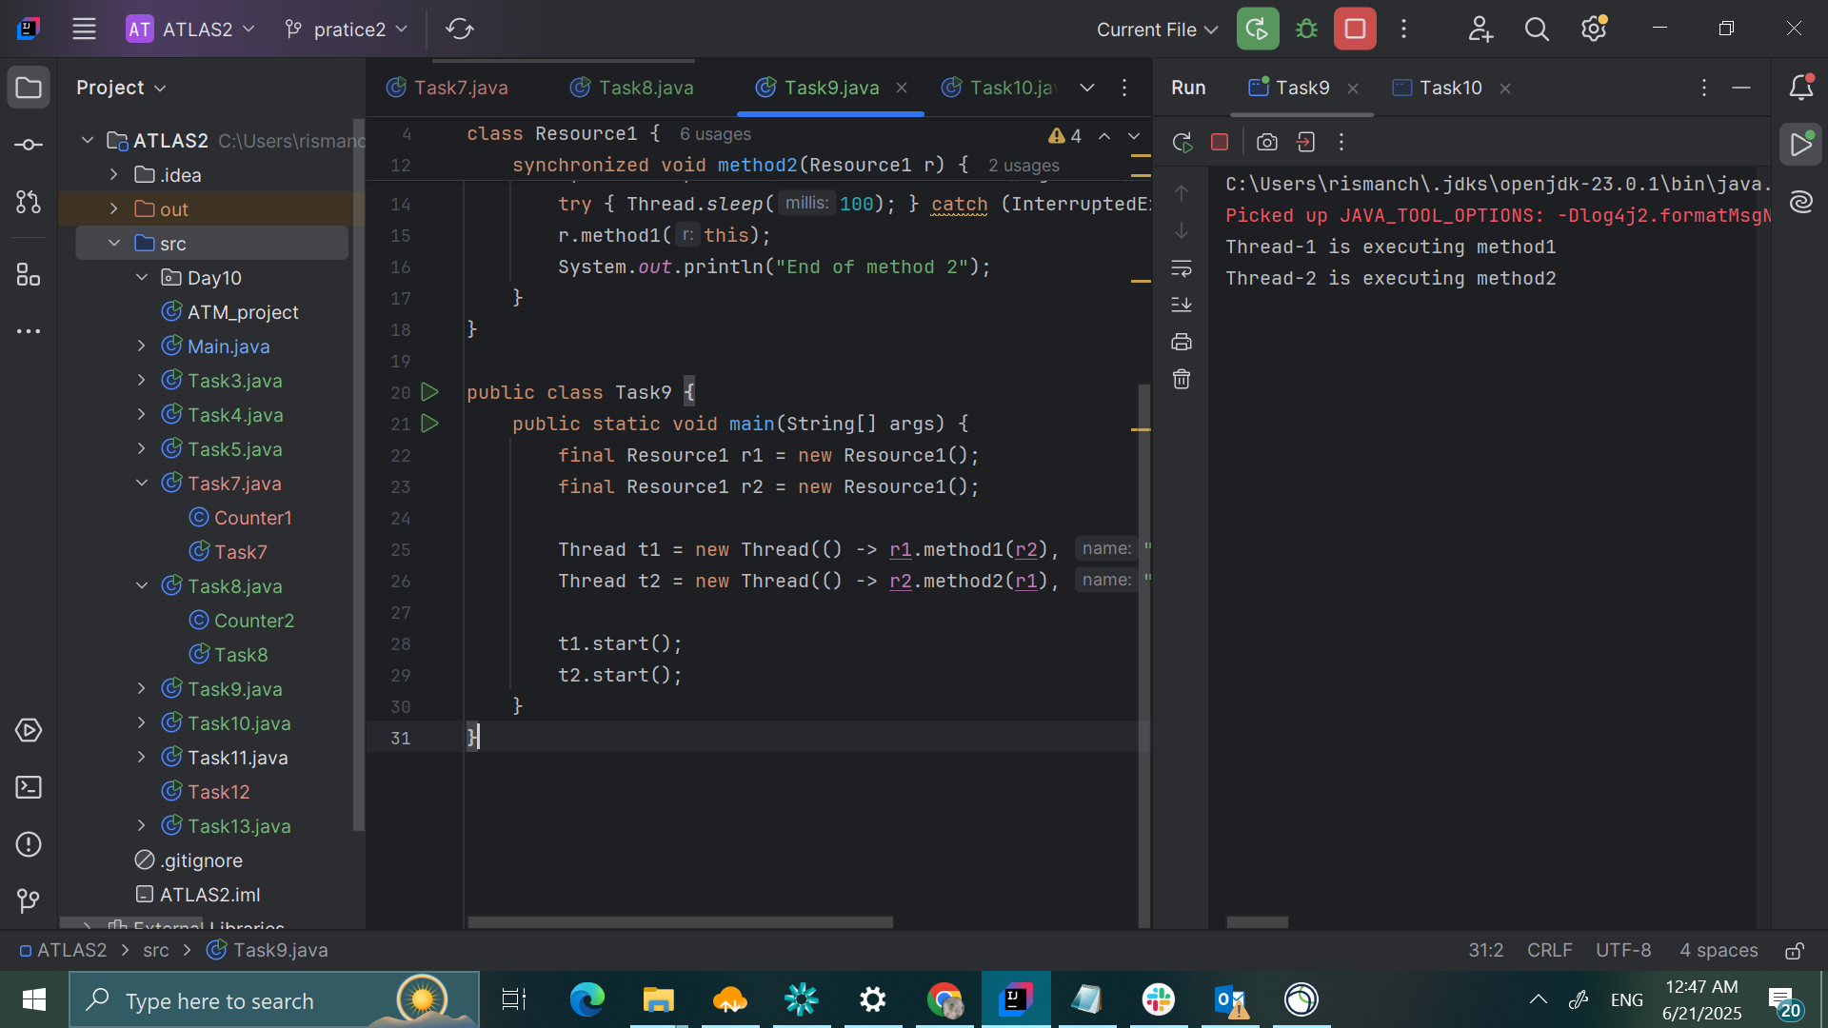

TASK10

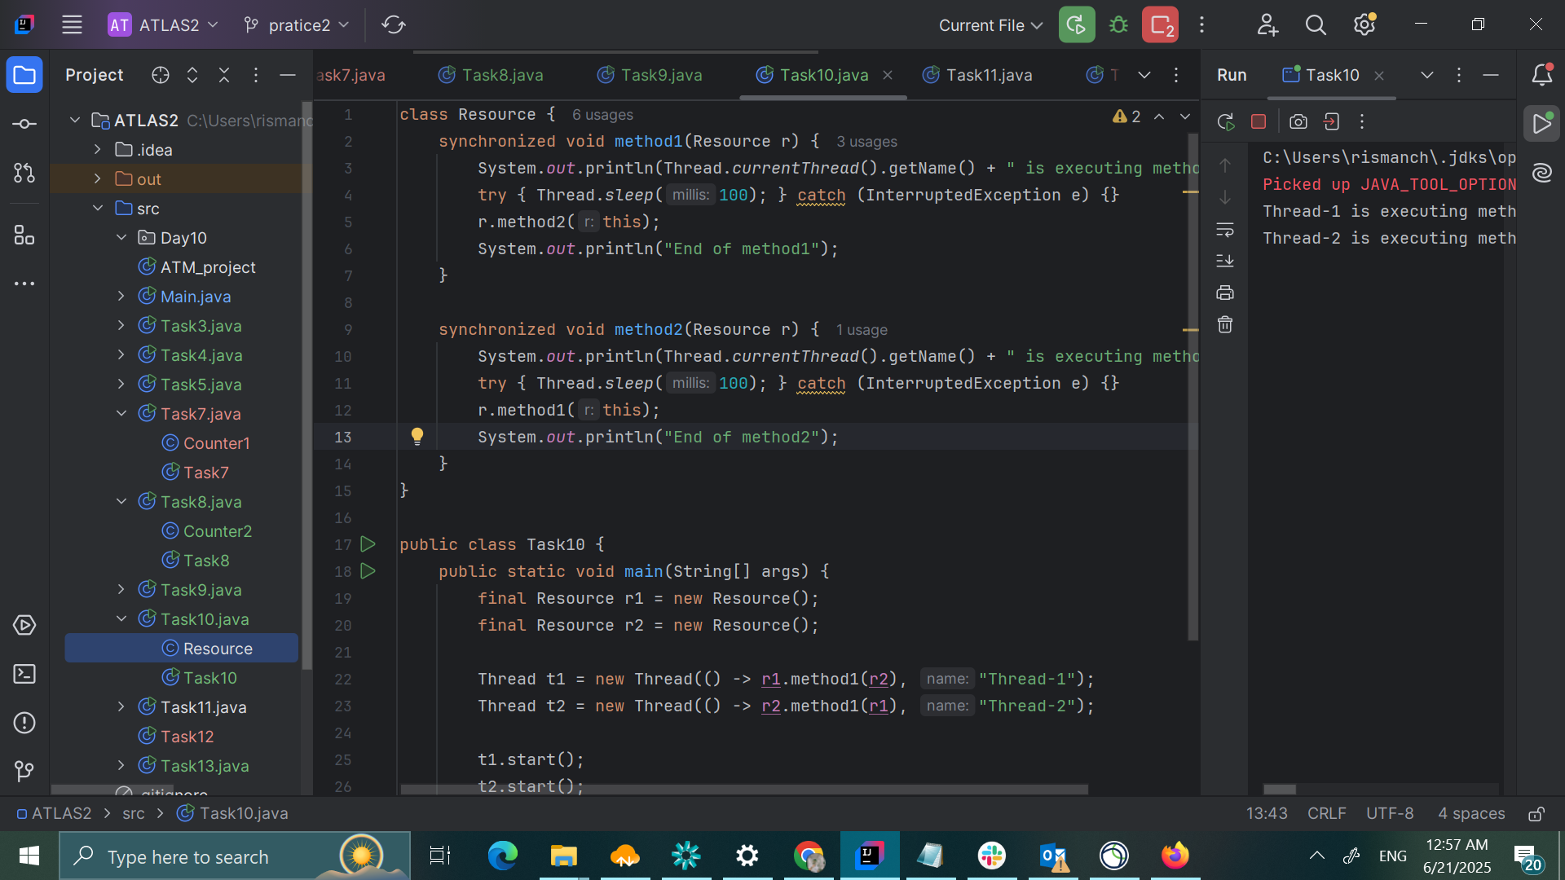

Task11

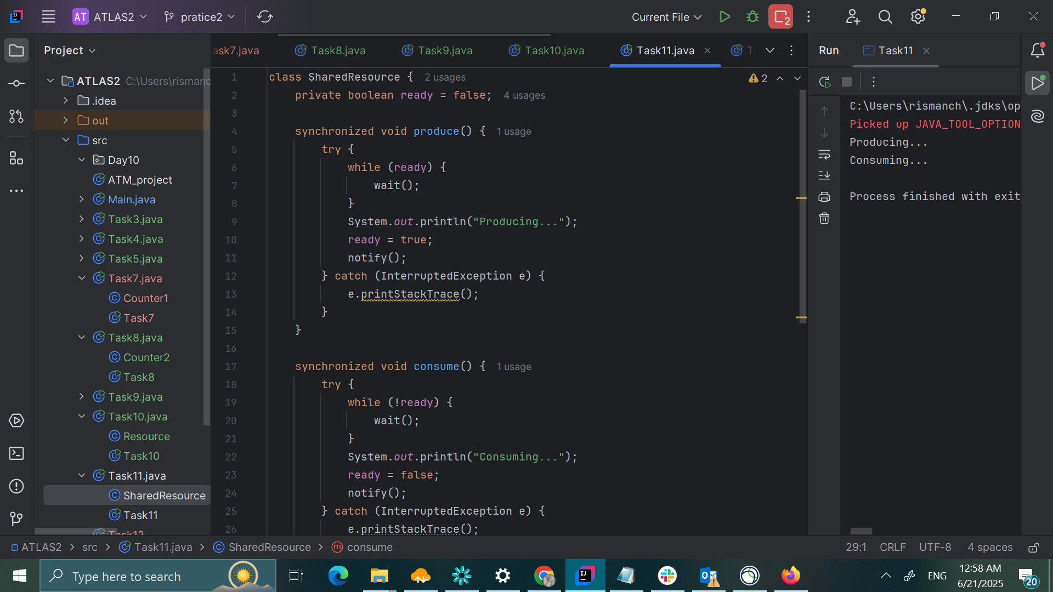

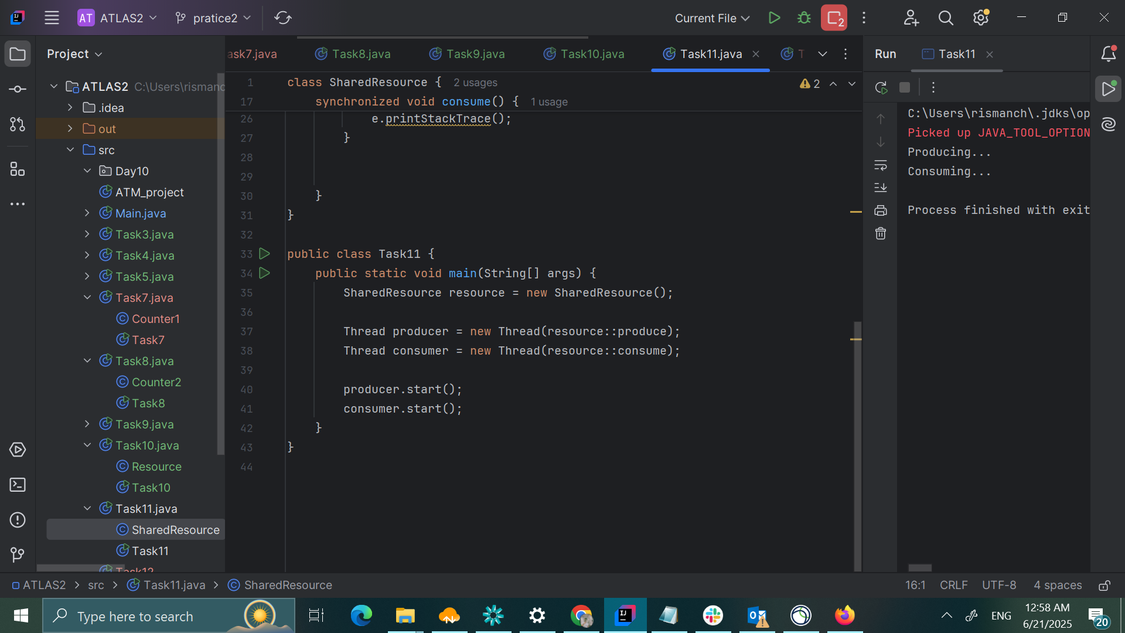

TASK12

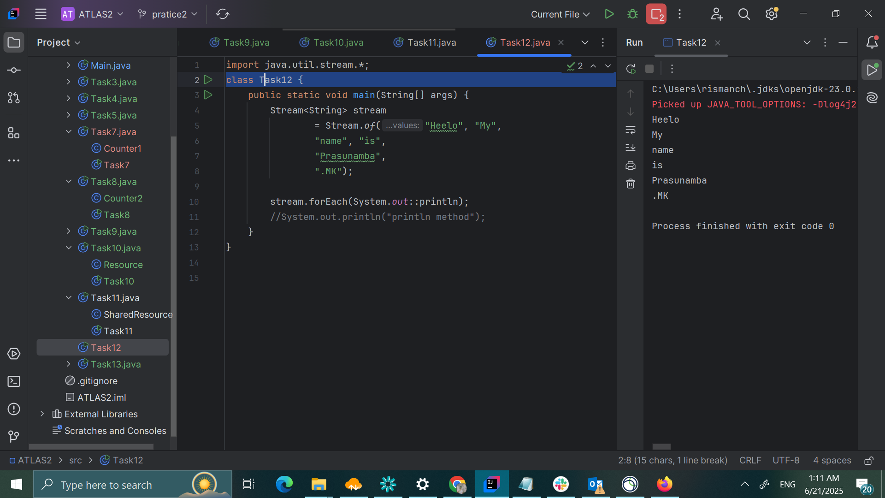

TASK13

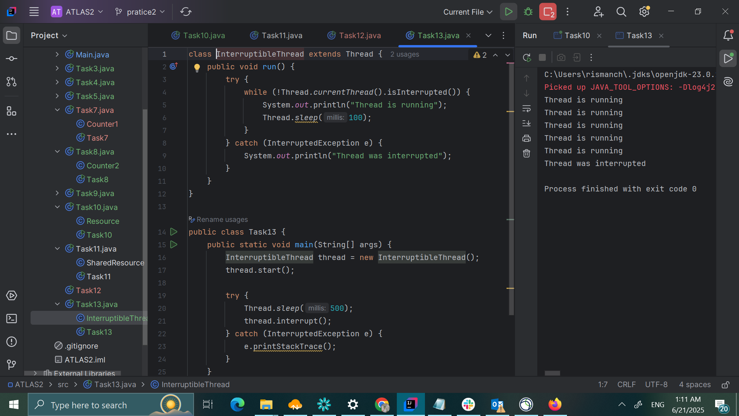

TASK14

What are Daemon threads? Explain…

Daemon threads are background threads in a program that provide support services to user threads. They are designed to perform tasks that are not critical to the application's core functionality and can be terminated automatically when all non-daemon (user) threads have finished their execution.

TASK18

